**BELFAST FESTIVALS FORUM BILLBOARD BOOKING FORM 2023**

Belfast Festivals Forum has secured access to a limited number of 48-sheet billboard sites located at major arterial route points around the city and metropolitan area. This is to help promote Belfast as a ‘City of Festivals’ and help festivals in Belfast to promote their events. These billboard sites can only promote festivals taking place within Belfast and are subject to availability.

* This initiative is available to current members of Belfast Festivals Forum only. Details of membership requirements are in the forum’s terms of reference (available on request)
* Forum members may book up to three sites of their choice for a 2-week advertising cycle in advance of their festival. If a member produces more than one festival per year, the Forum can assist a maximum of two festivals within one calendar year
* Depending on availability, there is the opportunity of late-notice additional sites to be allocated from vacant sites. These are at a very reduced fee and this should be arranged directly with the provider at time of booking
* Please note that costs for printing the required number of billboard posters must be met by the member and is not covered by the forum
* Availability within each advertising cycle is limited so please book sites early, ideally at least *three months* before your festival. This will ensure that you get the best choice of sites
* **Conditions of bookings: the festival must be open to the public; must be not-for-profit; must be featured on the current Belfast Festival Events Calendar and the Festival Organisation represented at a Forum meeting at least twice in the last 12 months**

**Guide to process:**

* Forum member requests booking form from [culture@belfastcity.gov.uk](mailto:culture@belfastcity.gov.uk)
* Forum member receives confirmation that booking is eligible (decision of forum steering group is final)
* Festivals coordinator links contracted provider with the forum member
* Media provider contacts forum member directly with all available sites during their chosen advertising cycle
* Forum member books up to three sites of their choice and arranges printing of posters (provider can give guidance for this)
* Forum member sends final version of poster design to [culture@belfastcity.gov.uk](mailto:culture@belfastcity.gov.uk) for approval of use of logo (please allow at least three working days)
* BCC confirms approval of logos
* Forum member prints posters
* Media provider mounts posters on sites and two week advertising cycle commences
* Whilst we will do our best to deal with late requests, please note that this is not always possible

**Logos to include on your billboard posters:**

* Belfast City Council is funding this initiative and Corporate Communications have asked if the Energiser logo (top left of this page) can be used. They have a variety of versions available on request. All artwork needs to be signed off by Corporate Communications before going to print.

**Design guidelines:**

* In order to maximise this opportunity, our billboard site supplier has supplied the following design guidelines for what makes a good billboard poster.
* Keep it simple – don’t expect people to see and remember more than 7-10 words.
* Everyone reads in a ‘Z’ pattern – starting at top left, move across then back to bottom left and across.
* Make it clear who is advertising – posters that make it clear who is advertising achieve 16% higher levels of recognition than those which don’t.
* Image attracts the eye – creatives that feature people or animals have 17%

higher recognition.

* Personality is even better – creatives with famous people have 45% higher levels of recognition.
* Humorous creative achieves 14% higher levels of recognition.
* Recognition is higher when the creative is considered original / different.
* Colour & Contrast – simple colours together with copy that contrasts against the background. Posters with good colour & contrast have 33% higher levels of recognition.
* White text is difficult to read and preferably avoided.
* You must have the consent in writing of any individual featured in publicity images.

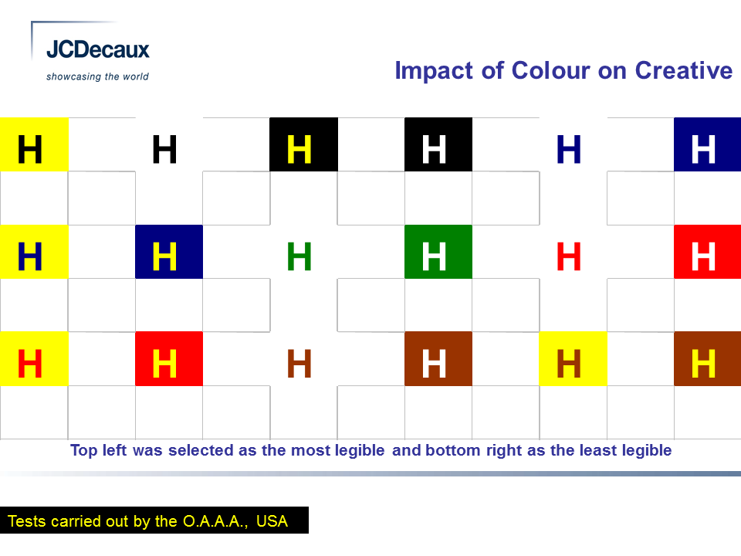

|  |  |  |  |  |  |
| --- | --- | --- | --- | --- | --- |
| **BELFAST FESTIVALS FORUM BILLBOARDS BOOKING FORM 2023** | | | | | |
| Contact name | **Krishan Tandon** | | | | |
| Position / Title | **Project Manager** | | | | |
| Organisation name | **Artsekta** | | | | |
| Address | **Glendinning House, 6 Murray Street, Belfast, BT1 6DN** | | | | |
| Telephone | **02890231381** | | | Mobile |  |
| Email | [**krishan@artsekta.org.uk**](mailto:krishan@artsekta.org.uk) | | | | |
| Website | [**www.artsekta.org.uk**](http://www.artsekta.org.uk) | | | | |
| Festival name | | **Belfast Mela** | | | |
| Festival Dates (start and end) | | 19th August – 27th August 2023 | | | |
| Summary of festival (max 25 words) | | Northern Ireland’s festival of world cultures | | | |
| **Agreement:** In submitting this application for booking Belfast Festivals Forum billboard sites, I confirm that the organisation that I am representing is a member of Belfast Festivals Forum. This Festival is included on the current Belfast Festival Calendar. The organisation has been represented at minimum 2 meetings of the Festivals Forum within the past 12 months (or apologies have been recorded). I have noted the requirements in the guidelines and agree to adhere to them. | | | | | |
| Name & Signature | | | K. Tandon | | |
| Date | | | 07/02/23 | | |
| **PLEASE RETURN THIS FORM TO:** [culture@belfastcity.gov.uk](mailto:culture@belfastcity.gov.uk). Belfast Festivals Forum, c/o Tourism Culture & Arts Unit, Belfast City Council**,** 9 Adelaide, Belfast BT2 8DJ. Tel: 02890 270227 | | | | | |

**PRIVACY NOTICE**

Belfast City Council is the Data Controller under the General Data Protection Regulation (GDPR) for the personal data it gathers for the purposes of membership of the Belfast Festivals Forum.

The Council accepts that you are providing your personal data on the basis of consent and are positively agreeing for the Council to hold and further use it.

The personal data may be shared internally within the Council with staff who are involved in providing this service and where necessary, between internal departments with the purpose of supporting an effective delivery of service.

It will be shared with the relevant contracted provider of goods or services, in order for them to liaise directly with you to provide you with these goods or services.

It may also be shared with the Chair of the Belfast Festivals Forum for the purposes of direct communication regarding the Belfast Festivals Forum.

Your personal data will not be shared or disclosed to any other organisation without your consent, unless the law permits or places an obligation on the Council to do so.

The personal data is held and stored by the Council in a safe and secure manner and in compliance with Data Protection legislation and in line with the Council’s Records Retention and Disposal Schedule.

If you have any queries regarding the processing of your personal data or wish to withdraw your consent to the processing of it, please contact us by email [culture@belfastcity.gov.uk](mailto:culture@belfastcity.gov.uk)

If you wish to contact the Council’s Data Protection Officer, please write to Belfast City Council, City Hall Belfast, BT1 5GS or send an email to [records@belfastcity.gov.uk](mailto:records@belfastcity.gov.uk)